Part A:

MCF:

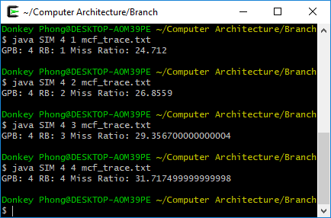

GOBMK:

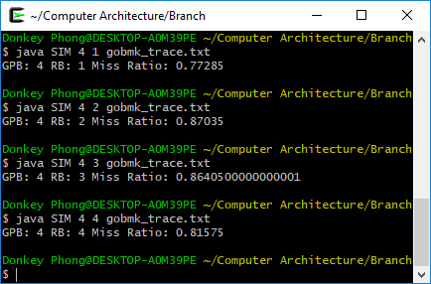

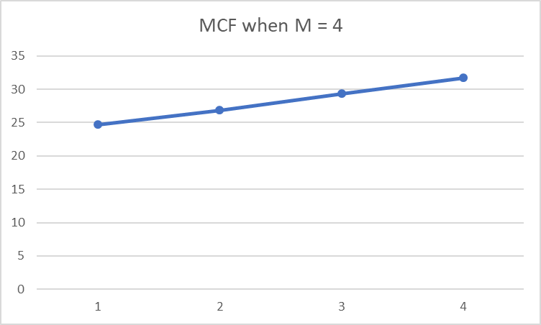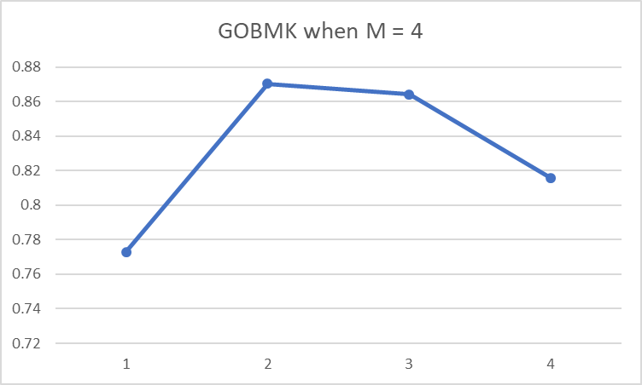

Part B:

MCF:

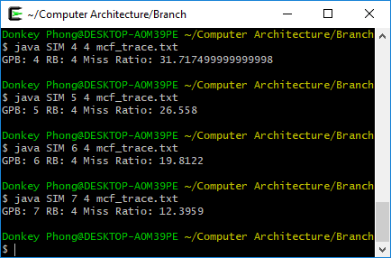

GOBMK:

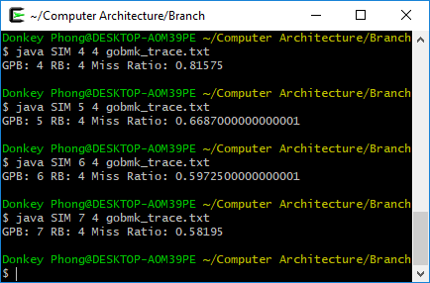

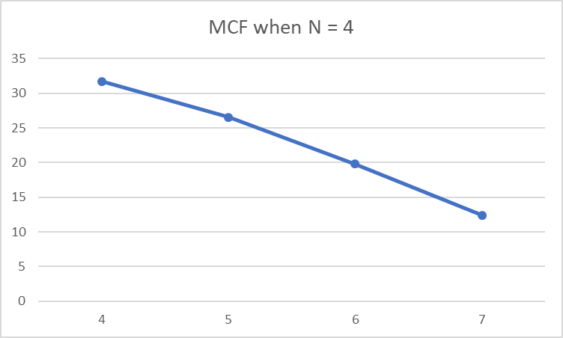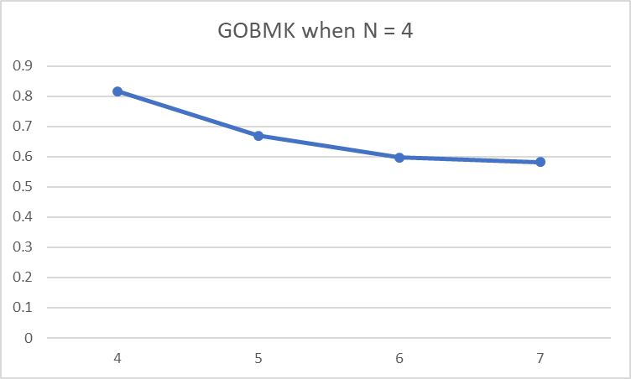

Part C:

MCF:

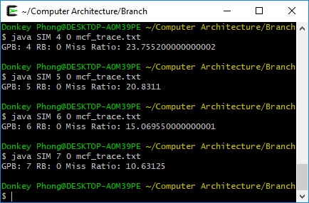

GOBMK:

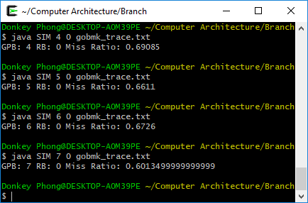

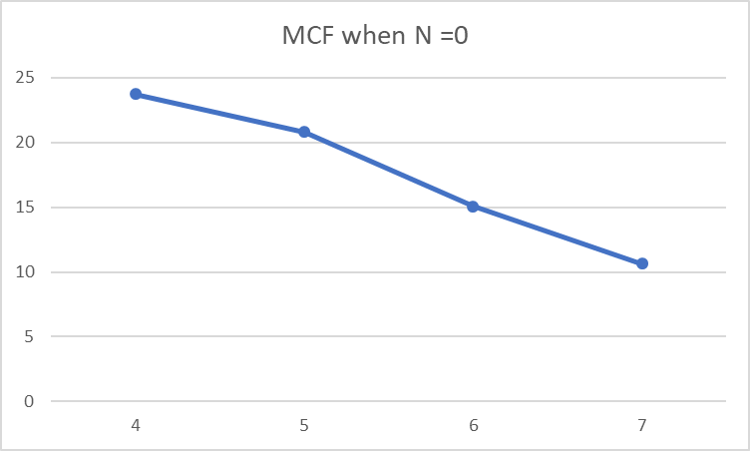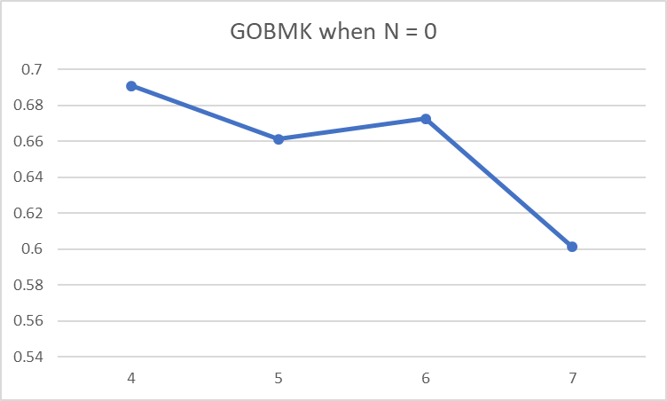

Comparing the two trends, there is a lower miss prediction ratio when N is 0 then when N is 4. In the MCF tracefile the miss prediction ratio is constantly going down as M increases. In the GOBMK tracefile the miss prediction ratio goes up a bit from 5 to 6 when N = 0 but then goes down from 6 to 7. When N = 4 for GOBMK the miss prediction ratio seems to be going down as M is increasing.